TRAXIS MANUFACTURING
Machine Utilization Report
Mon, Feb 2, 2026 — Wed, Feb 4, 2026

Executive Summary
During the reporting period (3 working days), 4 of 5 monitored CNC machines were active. The shop achieved an average utilization of 15% across active machines (based on actual cutting time — spindle warmup and air spinning are excluded). Machines logged 17.3 cutting hours and 61.4 spindle-only hours out of 116 available hours during shift time (6:00 - 19:00).

Shop Utilization: | 15% | Active Machines: | 4 of 5
Hours Cutting: | 17.3h | Hours Running: | 78.7h
Hours Available: | 116h | Active Machines: | 4 of 5
Green Target: | ≥ 70% | Warning Below: | < 50%

Utilization by Machine
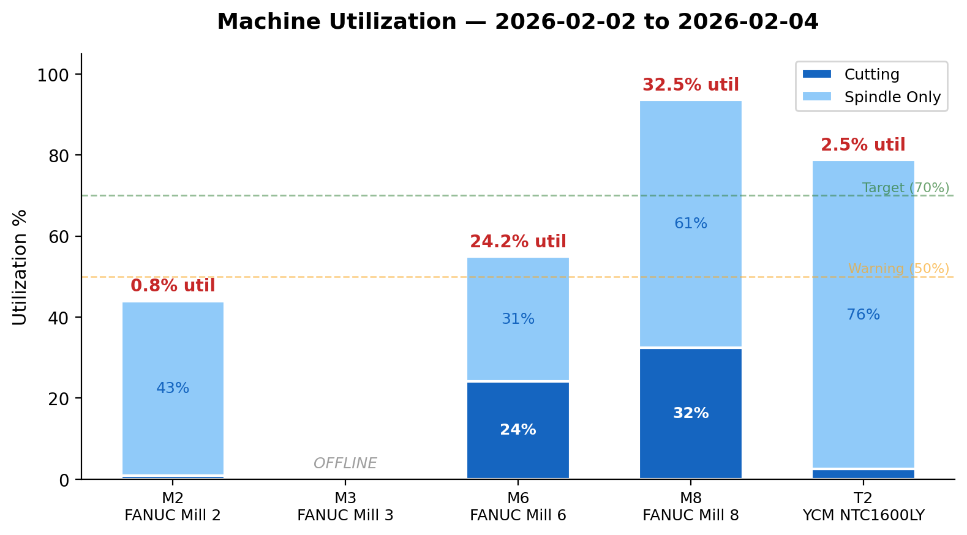

Detailed Breakdown
ID | Machine | Cutting | Spindle | Total | Running | Available | Status
M2 | FANUC Mill 2 | 0.8% | 43.2% | 44% | 12.8h | 29h | ❌ Critical
M3 | FANUC Mill 3 | 0% | 0% | 0% | 0h | 29h | — Offline
M6 | FANUC Mill 6 | 24.2% | 30.7% | 54.9% | 15.9h | 29h | ❌ Critical
M8 | FANUC Mill 8 | 32.5% | 61.1% | 93.6% | 27.1h | 29h | ❌ Critical
T2 | YCM NTC1600LY | 2.5% | 76.3% | 78.8% | 22.9h | 29h | ❌ Critical

Daily Utilization Trend
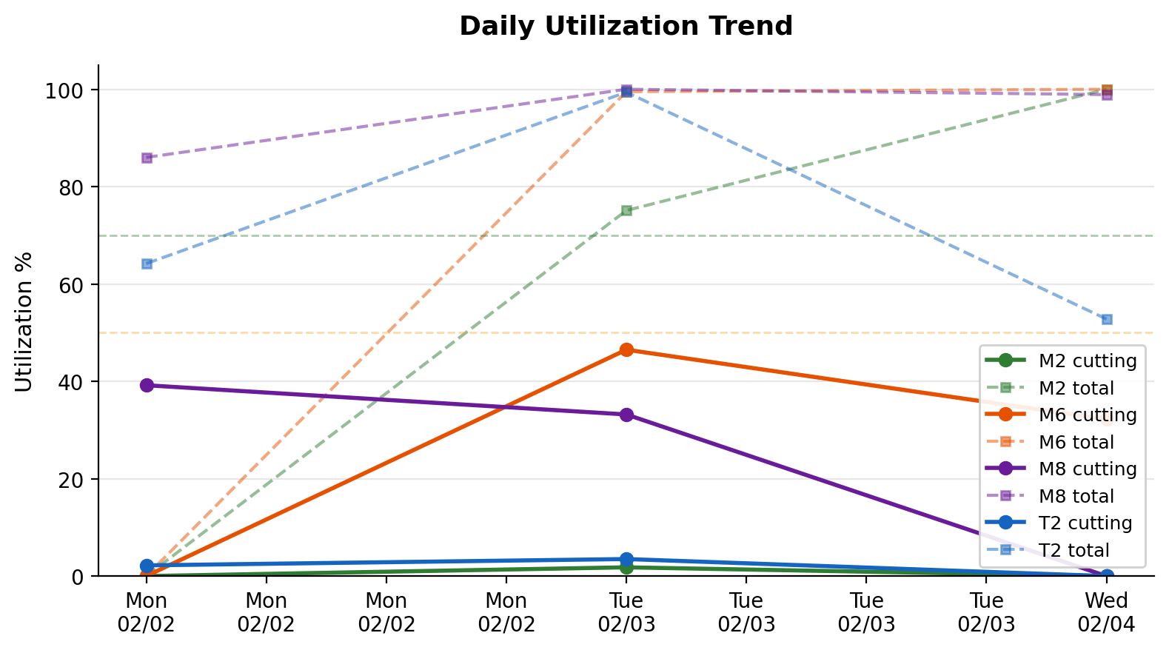

Daily Figures
Date | M2 | M6 | M8 | T2
Mon, 2/2 | 0% / 0% | 0% / 0% | 39.2% / 86% | 2.2% / 64.2%
Tue, 2/3 | 1.8% / 75.1% | 46.5% / 99.5% | 33.2% / 100% | 3.5% / 99.4%
Wed, 2/4 | 0% / 100% | 32.2% / 100% | 0% / 98.9% | 0% / 52.8%

Running vs. Idle Hours
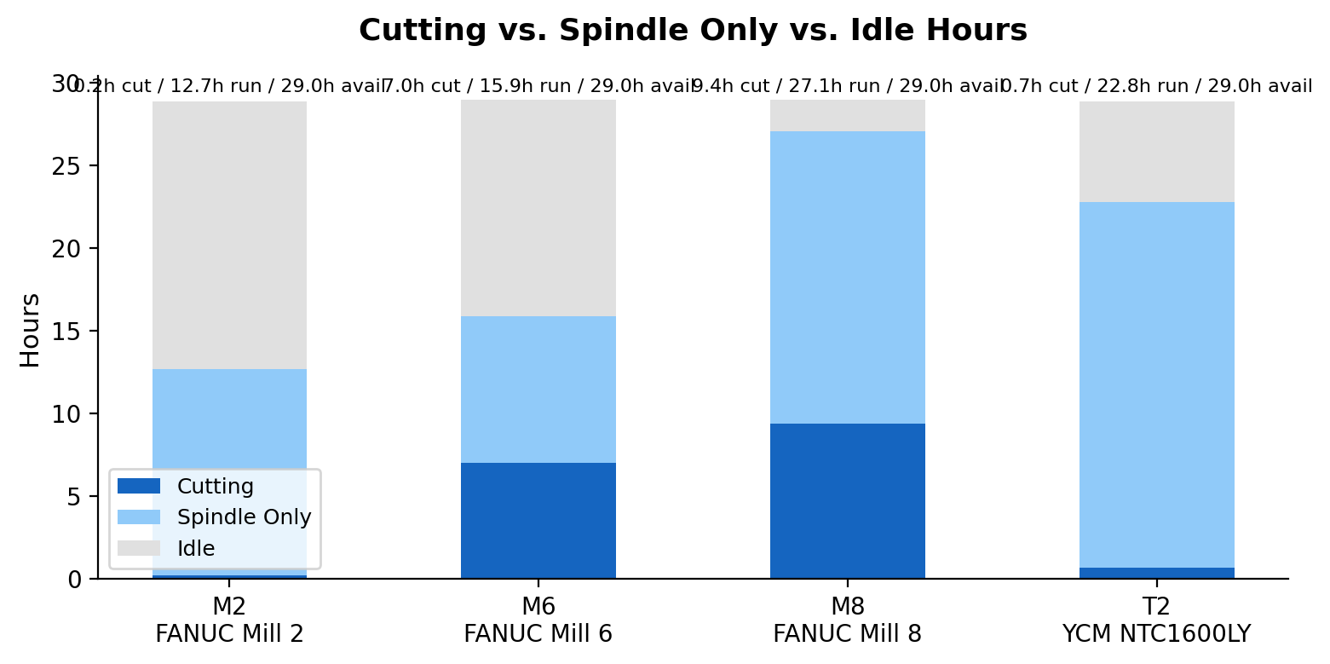

Notes & Methodology
Data collected via FOCAS2 protocol, polling each machine every 60 seconds from collector PC (WrkStationC).
Utilization is defined as the percentage of shift-hour samples where the machine spindle speed > 0 or run status = STRT/MSTR.
Shift hours: 6:00 - 19:00, Monday through Friday.
M3 (FANUC Mill 3) is currently offline due to a failed Ethernet adapter. A USB-to-Ethernet replacement is on order.
Machines M4, M5, and M7 (Robodrills) are not yet connected to the monitoring network.
M1 (Haas Classic) uses a proprietary protocol and is not FOCAS-compatible.

